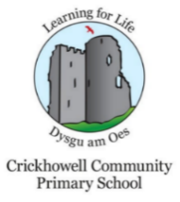
Newsletter- Summer Term 2019

Dear all, here is some information I hope you will find useful.

Dates for the Diary
Monday 20th May-PC Skyrme visiting Year 5
Year 6 shadow day
Tuesday 21st May-Year 1 Swimming
Swimming Gala at Brecon Leisure Centre
Wednesday 22nd-Foundation Phase on a Wild Walk
Thursday 23rd May-Year 3-6 to Hay festival
Friday 24th May-Non Uniform Day (raising funds for St Edmunds Church roof)
LAST DAY OF TERM
Important dates for the summer term-Also sent out last week
June 10- June 14th -Eco Week
June 24th-KS2 Field Events for Sports Day
June 26th-Sports Day
July 11th-Reports out to Parents
July 11th- Year 6 leavers Production
July 16th-Thank you Tea
July 18th-Year 6 Caribbean Evening

All the dates can be found on the website:
http://www.crickhowellcpschool.co.uk/calendar/?calid=1,2&pid=3&viewid=1

Year 6 at Stackpole
The Year 6 children have had an amazing week, packed full of outdoor activities, sun and fun! I'm sure everyone will be happy to be back in their own beds tonight!
Rags to Riches
Thank you for all your contributions of unwanted clothes this week. The bags were collected this morning. We raised £90.15.
Clubs
Wednesday-Cricket -Years 5/6
Wednesday-Space to Grow-Year 3/4
Thursday-Football-Years 5/6
Thursday-Kiddy Cook with Belinda

Attendance
Our current attendance for the school year is 96.23%, just above out target of 96%. This week, the top three classes with the highest attendance were:
2nd place-Year 2 with 98.75% , Joint 1st place-Year 6 and Reception with 100%
Well done to those classes!
Assembly Award Winners
Well done to all our assembly award winners this week.
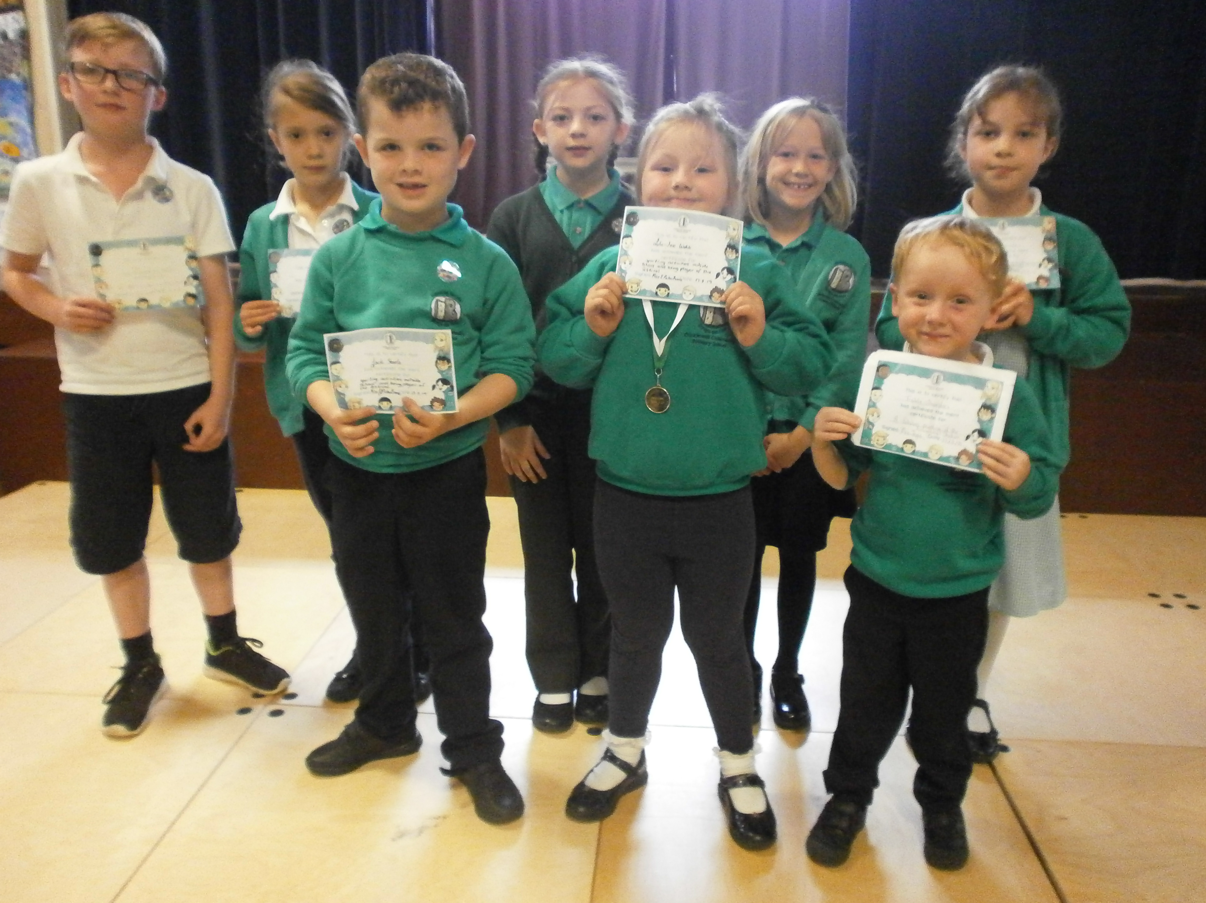
Enjoy the weekend!

